**Complaint Form (French Creole)**

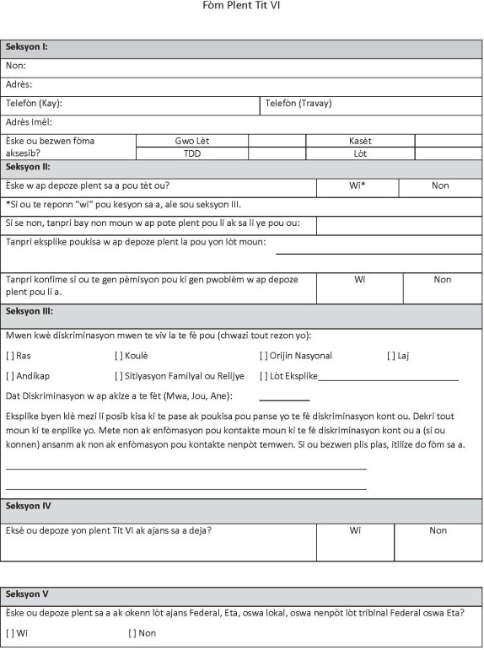

**Complaint Form (French Creole)**

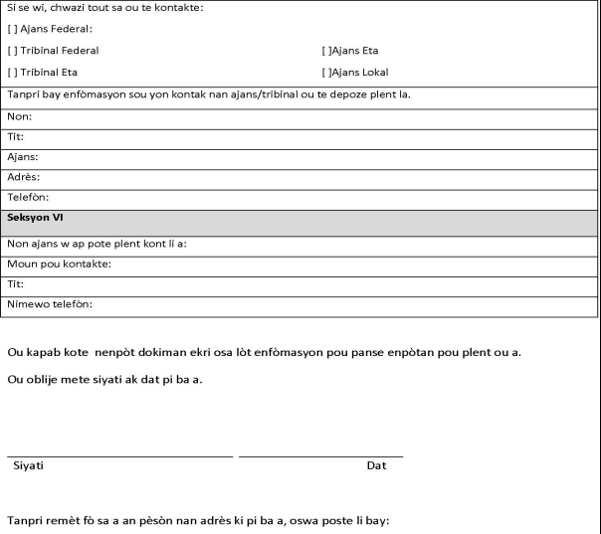

City of Fort Lauderdale,

Attn: Milos Majstorovic Title VI Coordinator

290 NE 3rd Avenue

Fort Lauderdale, FL 33301

954-828-5216